COMSATS University Islamabad
Attock Campus


Department Of Computer Science

Student Details

Registration No. | Name
FA24BSE041 | ROMASSA EMAN

ASSIGNMENT#04
CODE#01
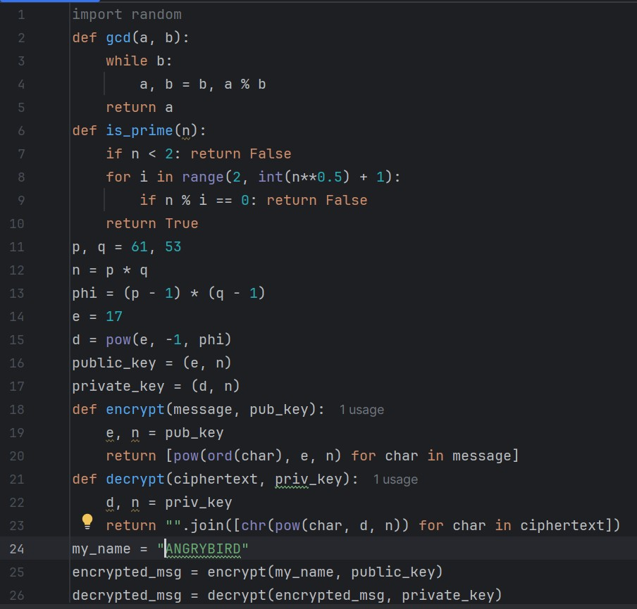
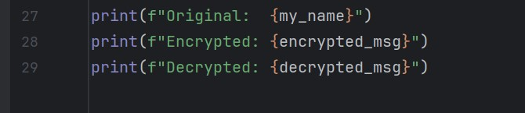
OUTPUT:
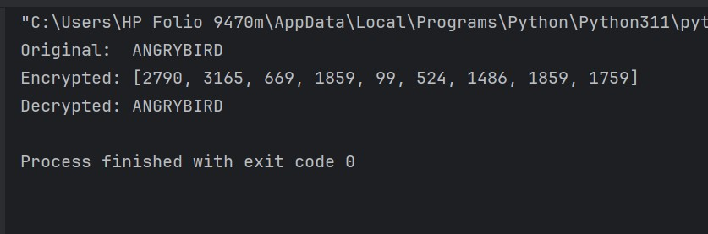
CODE#02
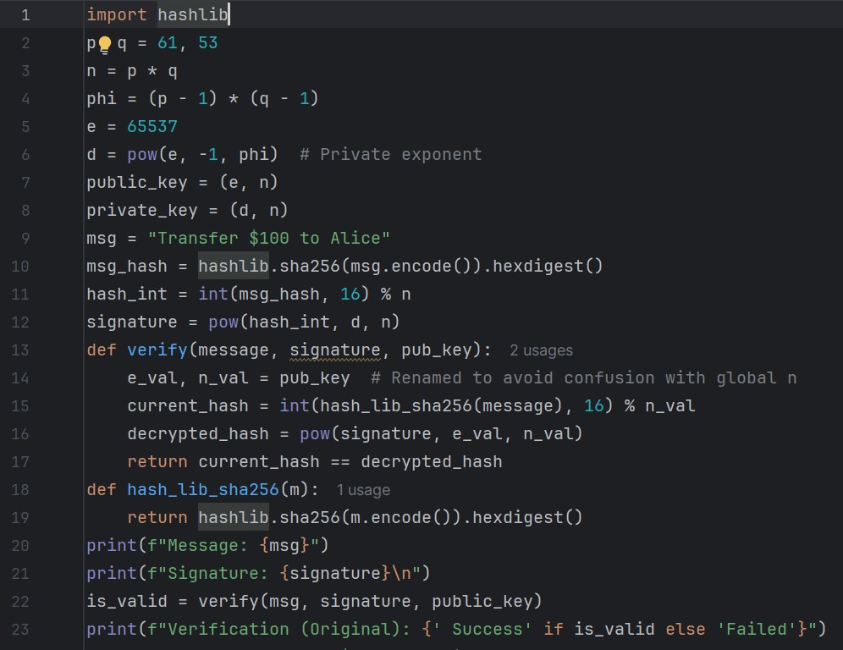
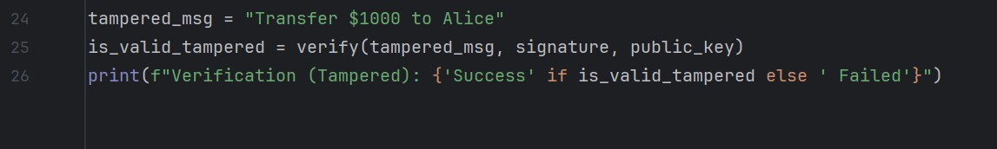
OUTPUT:
